**DAY #5:**

**Overview:**  Adding, Subtracting, Multiplying, and Dividing Decimals

**Estimated Time:** Approximately 45 minutes

**Explanation:**Today you will review prime and composite numbers, as well as complete activities using your knowledge of factors and multiples.

**Things to know:**

* When adding and subtracting decimals, remember to line up the decimals, which will line up your place values.
* There are no pre-made worksheets for today.

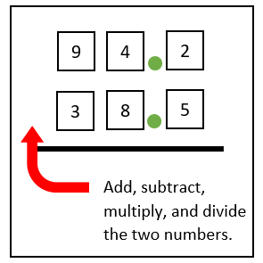

**Tasks:**

* Continue recording the daily temperature on your chart.
* Self-made Questions:
  + Shuffle your set of number cards.
  + Flip over 3 cards and place them in front of you in a horizontal line. Flip over 3 more cards and place these under each of the first three. Add a decimal to each number either after the first or second digit.
  + On a separate piece of paper, Add, Subtract, Multiply, and Divide the decimal numbers you created.
  + Repeat 4 times. You will have 16 problems on your separate of paper.
* Language Arts Connection:
  + Take some time to write a math story. You may write or type this story. Try to use each of the four mathematical operations (+, -, x, ÷) while dealing with decimals in your story. Some possibly story ideas are listed below, you may also develop your own.
    - The Decimal Duo are a superhero team that helps students learn about decimals…
    - A baker is having trouble with proper proportions in their bakery, which causes many interesting products…
    - A detective must use decimals to solve a difficult case…
  + Although it is not required, consider adding illustrations.
* Optional activity, play “Place Value” at <http://www.gregtangmath.com/placevalue>